**Project Design Phase-II**

**Technology Stack (Architecture & Stack)**

|  |  |
| --- | --- |
| Date | 29 October 2022 |
| Team ID | PNT2022TMID17711 |
| Project Name | Project - Smart Waste Management System For Metropolitan City |
| Maximum Marks | 4 Marks |

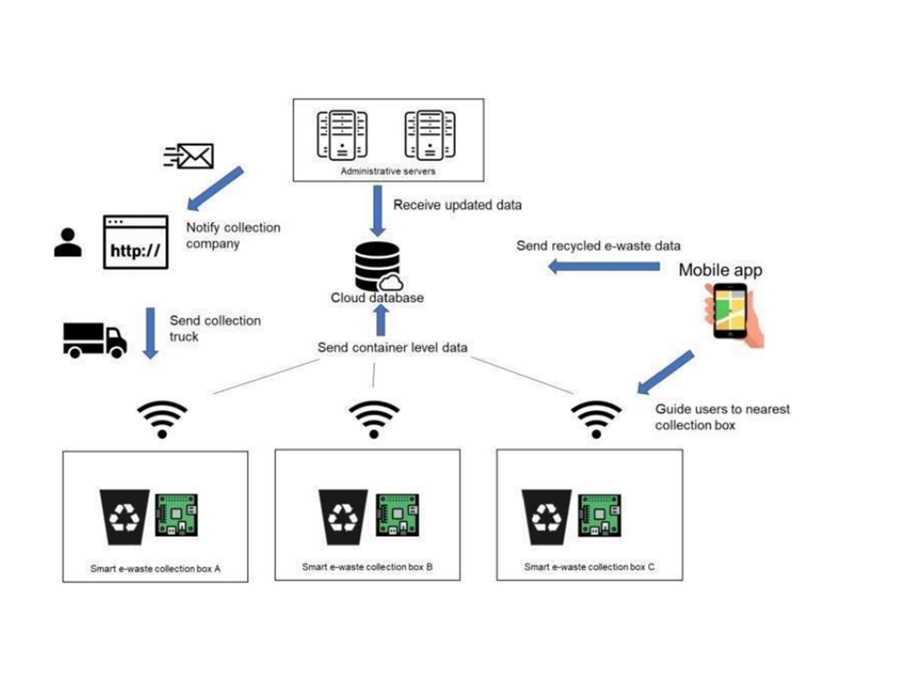**Technical Architecture:**

**Table-1 : Components & Technologies:**

|  |  |  |  |
| --- | --- | --- | --- |
| **S.No** | **Component** | **Description** | **Technology** |
|  | User Interface | IOT cloud platform /WEB PORTAL | HTML, CSS, NODE RED, JAVASCRIPT/MQTT PROTOCOL |
|  | Application Logic-1 | The bin waste data's are collected using sensor | Python/Ultrasonic sensor |
|  | Application Logic-2 | The data which is collected are monitored using IOT | IBM Watson STT Service |
|  | Application Logic-3 | To Get the location of the garbage | GPS |
|  | Database | MySQL is a relational database that is based on a tabular design.  NoSQL is non-relational and has a document based design. | MySQL, NoSQL |
|  | Cloud Database | Database service on cloud | IBM DB2, IBM Cloud etc.. |
|  | File Storage | File storage requirements | IBM Block Storage, local file system |
|  | External API-1 | External APIs expose a project's internal resources  to outside users or applications | IBM Weather API, etc.. |
|  | External API-2 | External API allow you to access third party resources that are available through RESTful web services | Aadhar API, etc.. |
|  | Machine Learning Model | The proper algorithm makes planning good.  It will guide the goodness character and which path should be taken and which garbage bin should be collected first | Python IDLE or Anaconda navigator or Jupiter |
|  | Infrastructure (Server / Cloud) | Application Deployment on Local System / Cloud  Cloud Server Configuration:  Cloud deployment is the process of deploying an application through one or more hosting models-software as a service (SaaS), platform as a service (PaaS) and or infrastructure as a service (laaS) that leverage the cloud  Local Server Configuration :  A local server gives you exclusive access to data and objects in a set of Windows folders called data directories | Cloud server- MySQL  Local server- HTTP |

**Table-2: Application Characteristics:**

| **S.No** | **Characteristics** | **Description** | **Technology** |
| --- | --- | --- | --- |
|  | Open-Source Frameworks | Micro web framework, Written in Python | Flask |
|  | Security Implementations | Provides Security rules to allow asses to data | Fire base, fire walls |
|  | Scalable Architecture | New features can be added | Node RED |
|  | Availability | Web application can be accessed from any where. | IBM Watson IOT platform, HTML, CSS, JavaScript |
|  | Performance | Provides real time data to web application which uses cloud platform and alerts garbage collector.  All truck drivers can access the application at same time | Cloudant DB IBM Watson IOT platform |